Zhibo Wang and Manisha Bhowmik

HANGMAN – cOUNTRY NAMES USER GUIDE

UNIT–D STAT–S OF AM–RICA

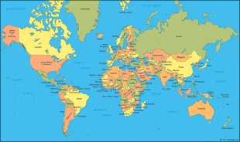

CS 110–C1

Fall 2018

This program was designed to simulate a typical Hangman game. Specific to this program is a word bank that consists of the names of all the countries in the world.

1. **Welcome Screen: Play Hangman–Country Names**

The program begins with a welcome screen asking the user if he/she would like to play the game. On the bottom left is a continue button that will take the user to the game. On the bottom right is a quit button that allows the user to exit the screen.

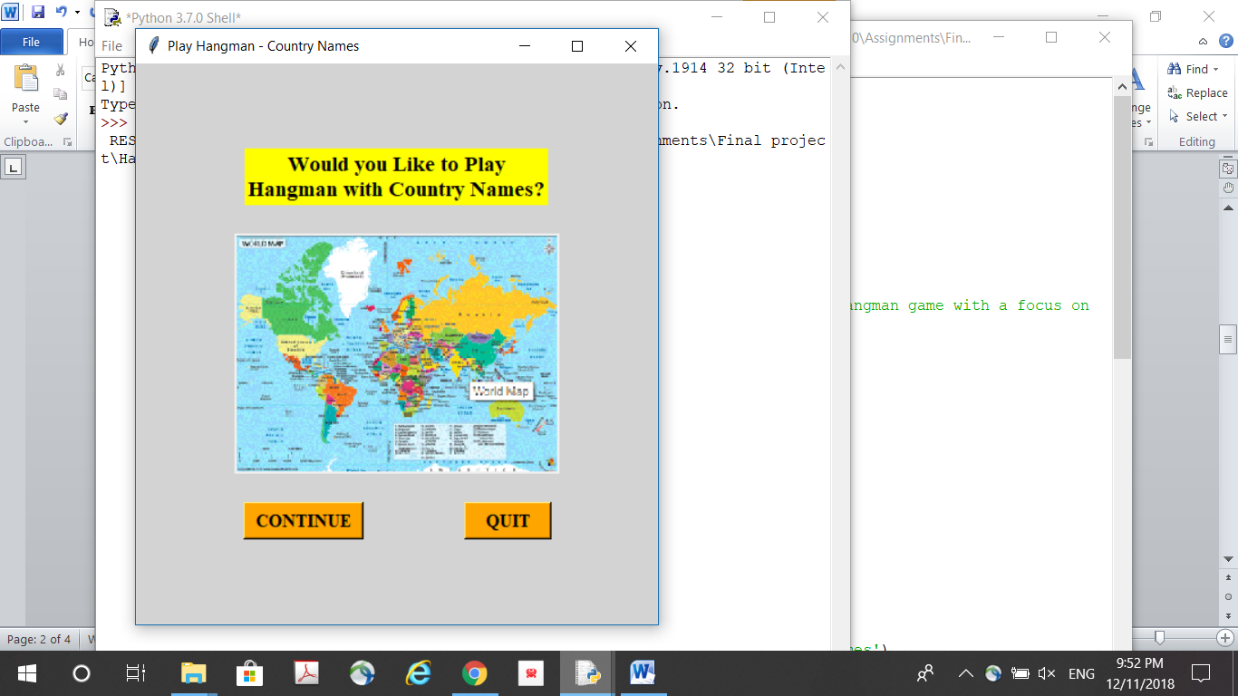

1. **Initial Game Interface and Initial Hangman Drawing Window**

After clicking the continue button, the user is taken to 2 new screens. One is the Draw Hangman screen in which a gallows that is commonly used in the Hangman game is drawn. The other screen displays the English alphabet buttons, space button, and blank lines for each letter of the country name the program has chosen at random for the user to guess. On the bottom left is the “play again” button that allows the user to restart the game at any point. On the bottom right is the “quit” button that allows the user to exit the program.

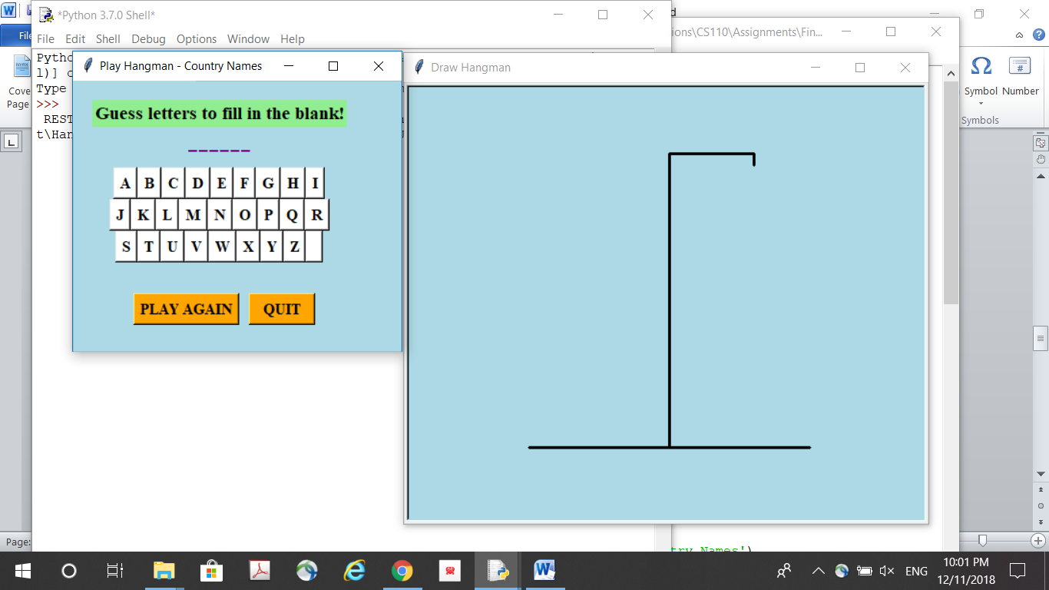

1. **Playing the Game**

To play the game, the user must guess and click letters of the country name based on the number of blank lines given. The user is given 6 chances for incorrect guesses. For each incorrect guess, a body part of the “hangman” is drawn. For each correct guess, the letter is filled in at the appropriate position(s). If the user succeeds in guessing the entire name with less than 6 incorrect guesses, then the user has won the game. If the user gets to 6 incorrect guesses, then the entire body of the (stick) hangman will be drawn and user will have lost the game.

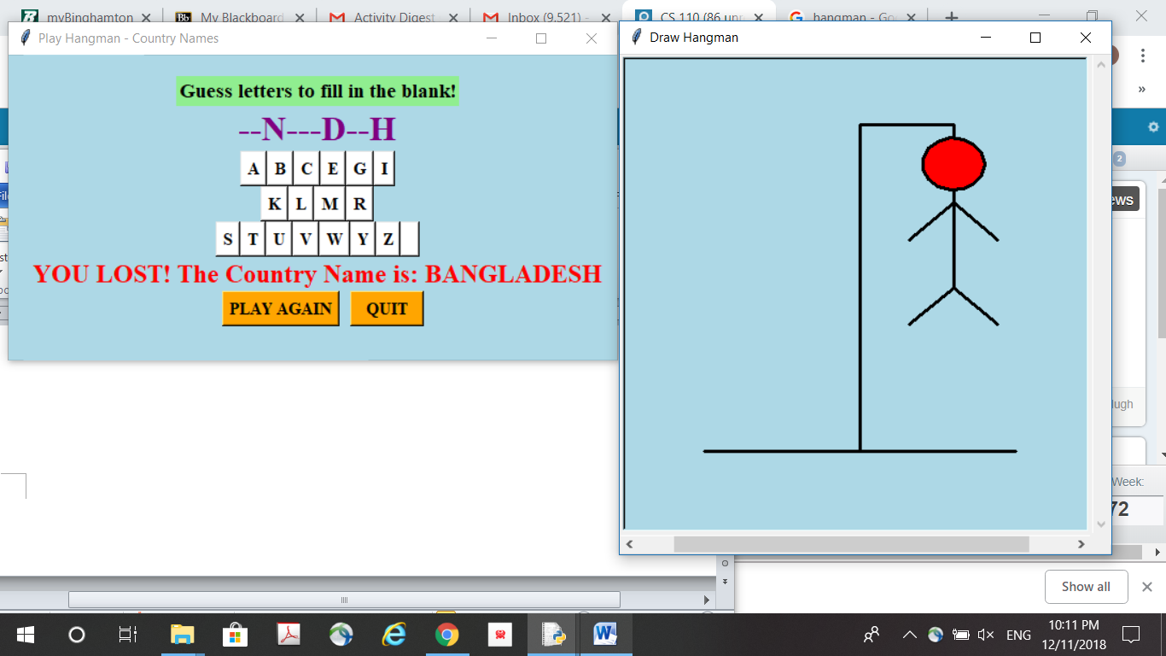

**An example of the user losing the game with 3 correct guesses and 6 incorrect guesses.**

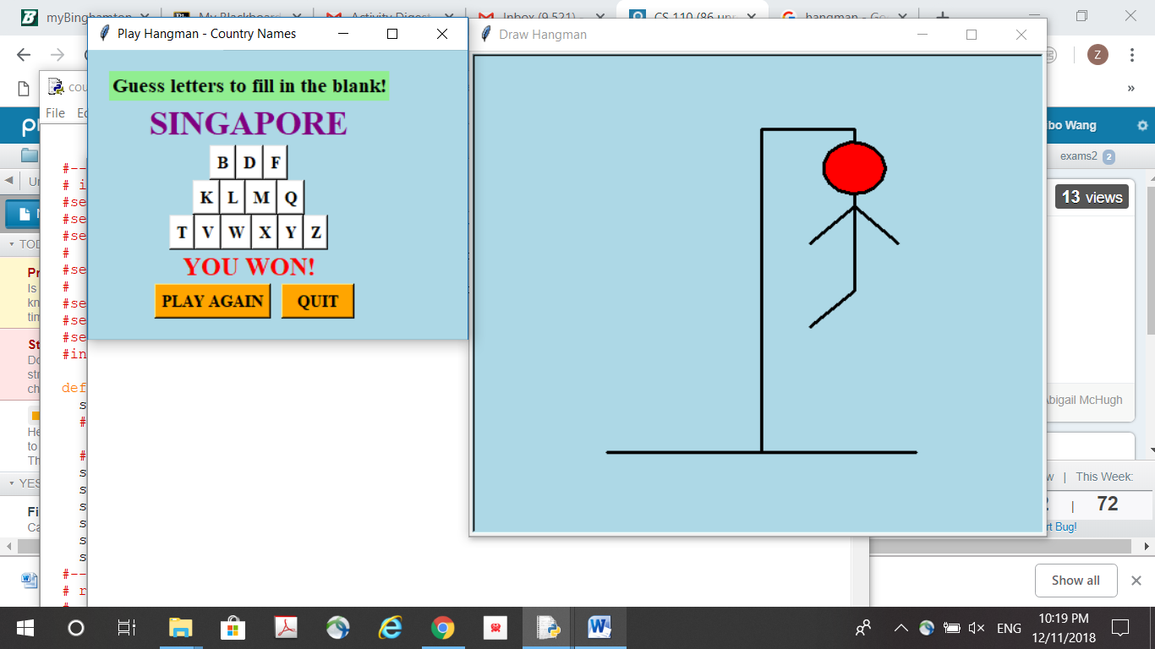

**An example of the user winning the game with 5 incorrect guesses.**